**Assignment-2**

Course: SC-374

Computational and Numerical Methods

Instructor: Prof. Arnab Kumar

Made by:

Yatin Patel – 201601454

Rutvik Kothari – 201601417

# **Problem: 1**

♦ **Statement:**

Consider the following functions $y=f(x)$, produce the first , the second and third-degree Taylor polynomials for each of the foregoing functions, using $a=1$ as the point of approximation for $logx$ and $a=0$ for the rest. In a suitably chosen neighbourhood of $a$, follow how the accuracy of a Taylor polynomial improves with the increasing degree. For this you will have to estimate the difference between $f(x)$ and its Taylor polynomials in a code. Present your results graphically for each function along with its Taylor polynomials of all three degrees.



$y = e^{x}$

♦ **Graphs:**

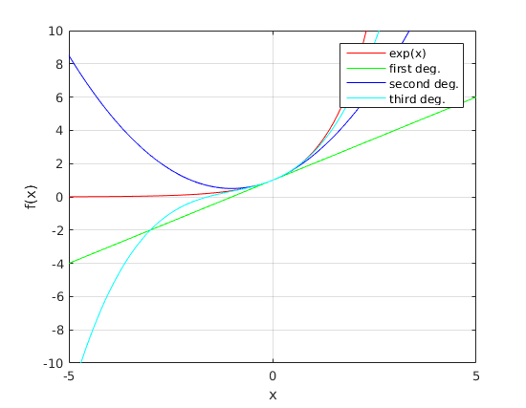

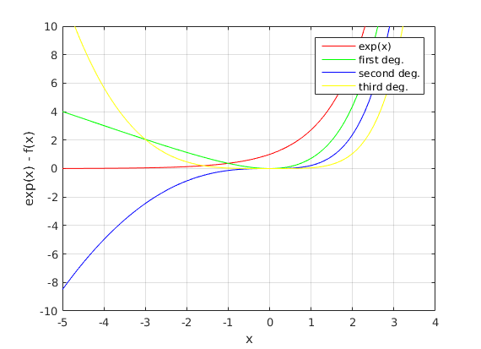

♦ **Observations :**

We have plotted the graph for first, second and third degree of function $y$.

Where $f1(x)=1+x$, $f2(x)=f1(x)+\frac{\left(x^{2}\right)}{2}$, $f3(x)=f2(x)+\frac{x^{3}}{6}$. We can say that as the degree of polynomial increases the function comes nearer and nearer to $e^{x}$. If we compare the second-degree polynomial with first degree polynomial, we can see that second-degree polynomial is more nearer to y as compared to first degree polynomial. And if we compare third degree polynomial with second degree polynomial, we can see that third-degree polynomial is more nearer to y as compared to second degree polynomial. In the second-degree polynomial, the highest degree term is even, so for $x<0$ the graph of second degree polynomial is above the function $y=e^{x}$ and first degree and third-degree polynomials are below the function $y=e^{x}$. for $x>0 , y=e^{x}$ increases very rapidly as compared to first, second and third-degree polynomials, because it contains much higher degree terms as compared to first, second and third-degree terms.

As we go away from $x=0$, the difference of the function $y-f\left(x\right)$ increases. Where difference of first degree polynomial increasing rate is more than second degree polynomial. And difference of second degree polynomial increasing rate is more than third degree polynomial.



$y=lnx$

♦ **Graphs :**

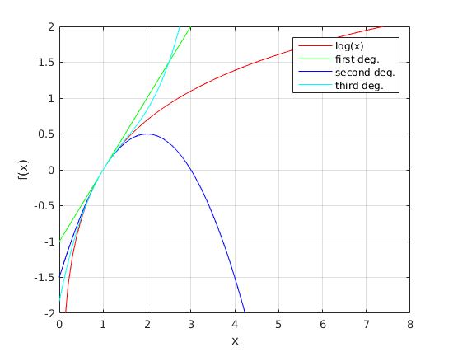

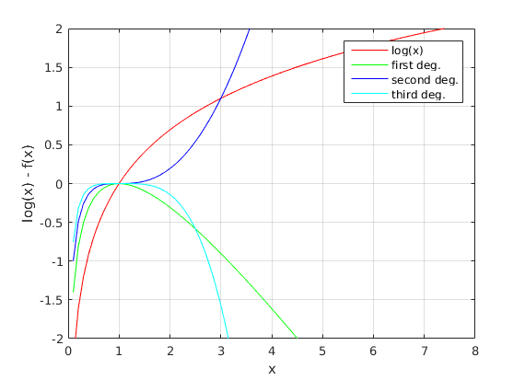

♦ **Observations:**

We have plotted the graph for first, second and third-degree polynomials of function $y$. Where $f1(x)=x-1$, $f2(x)=f1(x)-\frac{{\left(x-1\right)}^{2}}{2}$, $f3(x)=f2(x)+\frac{{\left(x-1\right)}^{3}}{3}$. We can see that third-degree polynomial is the closest to function y as compared to first and second-degree polynomials.

When $x > 1$, the value of the function will increase for odd degree polynomials and will decrease for even degree polynomials. This can be seen in the third figure when the second-degree curve is below $y$ and the first and third-degree curves are above $y$. The difference between $y$ and the given degrees of polynomials can be seen in the figure. The discussion stated above justifies it.



$y=sinx$

♦ **Graphs:**

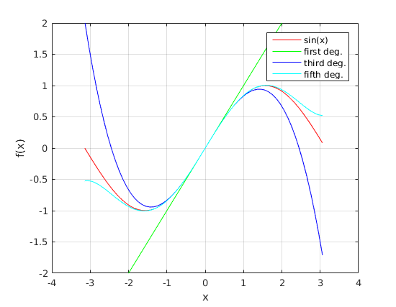

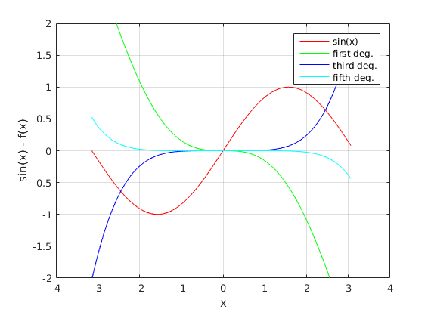

♦ **Observations:**

We have plotted the graph for first, second and third-degree polynomials of function $y$. Where $f1(x)=x$, $f3(x)=f1(x)-\frac{{\left(x\right)}^{3}}{6}$, $f5(x)=f3(x)+\frac{{\left(x\right)}^{5}}{120}$. We can see that fifth-degree polynomial is the closest to function y as compared to first and third-degree polynomials.

If we compare the third-degree polynomial with first degree polynomial, we can see that third-degree polynomial is more nearer to y as compared to first degree polynomial. And if we compare fifth degree polynomial with third degree polynomial, we can see that fifth-degree polynomial is more nearer to y as compared to third degree polynomial.

For the even degrees, we can say that they lie above $sin(x)$ for the negative $x$ And the odd ones are below but in the case of the increases values of $x$ in the positive side, the odd degree polynomials lie above, and the even ones are found Below $y$.

1. **y = cos(x)**

♦ **Graphs:**

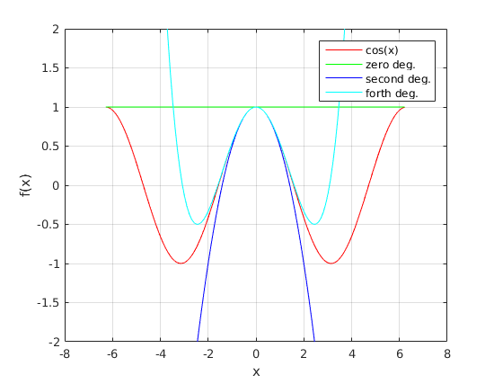

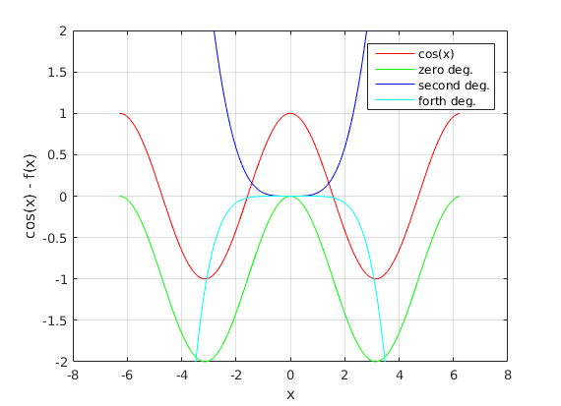

♦ **Observations:**

We have plotted the graph for first, second and third-degree polynomials of function $y$. Where $f0(x)=1$, $f2(x)=f0(x)-\frac{{\left(x\right)}^{2}}{2}$, $f4(x)=f2(x)+\frac{{\left(x\right)}^{4}}{24}$. We can see that fourth-degree polynomial is the closest to function y as compared to zeroth and second-degree polynomials.

If we compare the second-degree polynomial with zeroth degree polynomial, we can see that second-degree polynomial is more nearer to y as compared to zeroth degree polynomial. And if we compare forth degree polynomial with second degree polynomial, we can see that forth-degree polynomial is more nearer to y as compared to second degree polynomial.

We also observe that the zeroth order approximation and the second order approximation lie above the equation y = cos(x) while the forth order equation lies below the given equation.